Minoo Ahmadi

Homework 1

**Part I**

1. A mean of 35.17 (SD = 29.32) was found for the population. A median of 27.5 indicates a right-skewness in the data, which is probably due to the maximum value of 150 for the subject with ID = 27. The variance is 860.15.
   1. H0: , H1:
   2. T-distribution: t(20)

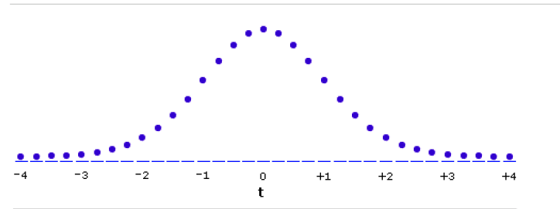

* 1. Using an online t-table, the critical t-value for a two-sided test at alpha level of .05 is 2.086.
  2. t(20) = 1.28, which is smaller than (doesn’t exceed) the critical t-value.
 $$t=\frac{\overline{X}- μ}{\frac{S}{\sqrt{n}}} = \frac{39.04-30}{\frac{32.15}{\sqrt{21}}} =1.28$$

 3. Using an online t-table: p>.05.
  4. $\%95CI = 39.04± 2.086 × \frac{32.15}{\sqrt{21}}=[24.41 53.68]$. We can be 95% confident that the population mean commute time is between 24.41 and 53.68 minutes. Note that this interval includes the mean of 30 and that’s why we fail to reject the null.
  5. We failed to reject the null hypothesis.
  6. A two-sample t-test was performed to compare the sample mean commuting time in the sample to a hypothesized population mean of 30. Using an alpha level of 0.05, the sample mean of 39.04 (SD = 32.15) was found not to be statistically significantly different from this value (t(20) = 1.28, p > 0.05 (two-tailed)), suggesting that the mean commuting time in the sample is not significantly different from 30 minutes.

One Sample t-test

data: samp.data$commute

t = 1.2894, df = 20, p-value = 0.212

alternative hypothesis: true mean is not equal to 30

95 percent confidence interval:

24.41011 53.68513

sample estimates:

mean of x

39.04762

1. Since we know the population variance, we’ll use a Z test. Here is the z distribution:

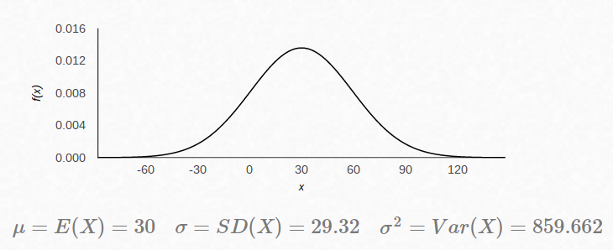

The z statistic:

$$z=\frac{\overline{X}- μ}{\frac{σ}{\sqrt{n}}}= \frac{39.04- 30}{\frac{29.32}{\sqrt{21}}}= 1.41$$

It’s less than 1.96 (2SD from the mean), so we fail to reject the null. We get the same result by looking at a Z table. The value we get for a z-score of 1.41 is .9207 which falls within the 95% interval.

%95CI = [26.50 51.59]

One-sample z-Test

data: samp.data$commute

z = 1.4137, p-value = 0.1575

alternative hypothesis: true mean is not equal to 30

95 percent confidence interval:

26.50391 51.59133

sample estimates:

mean of x

39.04762

**Part II**

min max range

1.520000e+02 2.280000e+02 7.600000e+01

median mean CI.mean.0.95 var

1.825000e+02 1.845000e+02 4.191929e+00 3.182254e+02

std.dev

1.783887e+01

Mean and median are about the same, which indicates a normal distribution (no significant skewness).



The histogram shows that the data for hypertension is (acceptably) normally distributed.



The boxplot does not show outliers.